

Experiment 3

Name of the Student: -Rutuja Rajesh Kini Roll No:-53

Date of Practical Performed: -5/2/25 Staff Signature with Date & Marks

# Aim: Write a program to perform Group Communication.

**Theory:** Group communication refers to a communication paradigm where a message is sent to a group of processes rather than to an individual process. It is commonly used in systems where multiple processes need to collaborate or synchronize with each other. The goal is to manage the communication among distributed entities efficiently and correctly, ensuring that messages are delivered to all members of the group in a reliable, timely, and consistent manner.

# Types of group communication:

1. **Unicast Communication** A type of communication where a message is sent from one sender to a specific receiver (a single process).
2. **Multicast Communication** A communication model where a message is sent from one sender to multiple receivers (a group of processes) at once. It is a more efficient version of sending messages individually (unicast) to each receiver.
3. **Broadcast Communication** Broadcast sends a message to **all** processes in a network or system, without targeting any specific group. In some cases, it can also be viewed as a form of multicast where the target group is the entire network.
4. **Anycast Communication** A type of communication where the message is sent to the nearest member of a group (based on some defined criteria, usually distance or latency), rather than to all members.

# Modes of Communication in Group Communication:

1. **Synchronous Communication** In synchronous communication, the sender waits for an acknowledgment or response before proceeding further. The sender and receiver are synchronized in terms of timing.
2. **Asynchronous Communication** In asynchronous communication, the sender does not wait for an acknowledgment or response and proceeds immediately after sending the message. There is no guarantee about the timing of delivery or acknowledgment.
3. **Point-to-Point Communication** Point-to-point communication is a one-to-one interaction between two processes, where each message is directed from one sender to one receiver.



# Code:

**Server-**

#Server import socket

import threading

# Function to handle communication with each client def handle_client(client_socket, client_address):

print(f"New connection: {client_address}") while True:

try:

message = client_socket.recv(1024) if not message:

break # No more data from the client

print(f"Message from {client_address}: {message.decode('utf-8')}") broadcast(message, client_socket) # Send message to all clients

except:

break

client_socket.close()

print(f"Connection closed: {client_address}")

# Function to broadcast messages to all connected clients def broadcast(message, sender_socket):

for client in clients:

if client != sender_socket: try:

client.send(message) except:

clients.remove(client)

# Set up the server socket

server_socket = socket.socket(socket.AF_INET, socket.SOCK_STREAM) server_socket.bind(("0.0.0.0", 5555)) # Bind to all interfaces on port 5555 server_socket.listen(5) # Listen for up to 5 incoming connections

clients = []



print("Server started. Waiting for clients...")

# Accept client connections and handle them in separate threads while True:

client_socket, client_address = server_socket.accept() clients.append(client_socket)

threading.Thread(target=handle_client, args=(client_socket, client_address)).start()

# Client-

#client

# -*- coding: utf-8 -*- """

Created on Wed Feb 5 11:32:47 2025

@author: STUDENT """

import socket import threading

# Function to receive messages from the server def receive_messages(client_socket):

while True: try:

message = client_socket.recv(1024)

print(f"\nNew message: {message.decode('utf-8')}") except:

print("Connection lost.") break

# Set up the client socket

client_socket = socket.socket(socket.AF_INET, socket.SOCK_STREAM) client_socket.connect(("127.0.0.1", 5555)) # Connect to the server

# Start the thread for receiving messages threading.Thread(target=receive_messages, args=(client_socket,)).start()



# Send messages to the server while True:

message = input() if message:

client_socket.send(message.encode('utf-8'))

# Output:

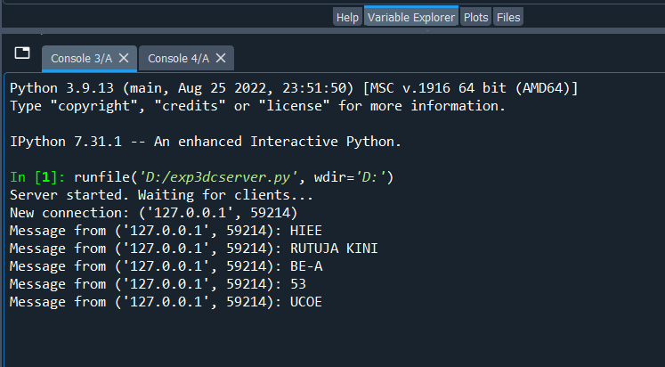



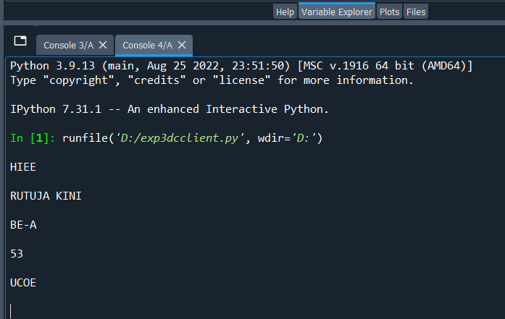

**Conclusion:** Thus, we have implemented group communication.